Product | SMART CPR Training Model (Sherpa X) | Model | BT-SHERPA-XM
Manufacture | BT INC / South Korea | Q'ty | 1 SET
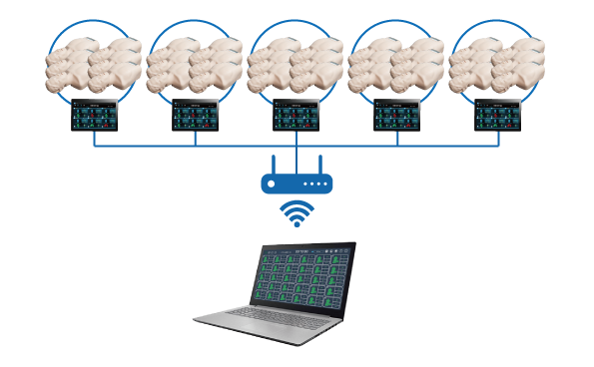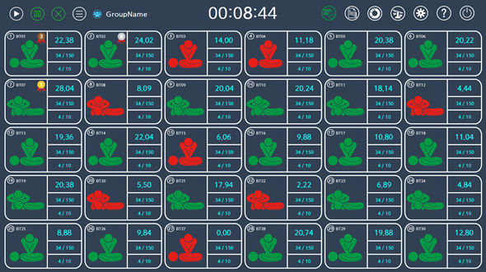
A. FEATURES
1. SMART CPR training model(Sherpa X), Training & Evaluation up to 1:30
- Connect up to 6 manikins to 1 tablet through Bluetooth
- Tablet and laptop are connected with WiFi, Possible to train & evaluate up to 1:30
- Easy to use and user friendly GUI software
- CPR training and evaluation through its own S/W
- Saving and printing the training result through its own S/W
- Evaluation result can be saved as JEPG or Excel format
- Change layout to 1:12, 1:18, 1:24, 1:30 according to the system’s setting
- Set the guideline
- Group setting and typing the user name
- On/Off the LED display panel of the manikin
- Make a statistics and analyze the results

2. A case set for Multi-system
- Charge & Store tablets
- Wifi router is included
- Make sure the safety with a lock

3. CPR Training Model ; Sherpa X
· Wireless connection with a tablet or a smartphone through Bluetooth
- Easy to use and user friendly GUI software
- Connect up to 6 manikins to 1 tablet (tablet is optional)
- Compression depth & rate and hand position, ventilation volume can be checked through its own S/W
- Saving and printing the training result through its own S/W
- Scoring the training result and rank the result in order of high scores
- Select the mode between Training mode & Evaluation mode
· LED Display embedded in the manikin
- Real-time feedback of chest compression depth and rate with LED lamp
- Display total number of compression and the number of good compression
- Display the instant depth of compression
- Detect incomplete recoil
- Detect the good chest compression when depth and rate are good and give sound feedback (Sound On/Off)
- Display the feedback about ventilation such as volume and expiratory time
- Display the total number of ventilation and the number of good ventilation
- Display the ventilation volume

· Manikin Body
- Observable chest rising during ventilation
- By attaching offering magnetic stickers to AED trainer pads, AED trainer pads can be used semi-permanently
- Easy to replace the face skin and lung ; sanitary training environment
- The storage bag can be used as a training mattress

B. COMPONENTS
- Laptop with software : 1set
- Case set for Multi-system : 1set (Wifi router, Multi-charger, Extension cord, Cabinet )
- SMART CPR training model : Optional (Depends on the Multi-system’s composition)
- 10.1” tablet : Optional (Depends on the Multi-system’s composition)

C. WEIGHT & SIZE
- Laptop : Depends on each laptop’s specification
- Case set for Multi-system : 20㎏ (500×600×500㎜)

