Product | ALS Training Simulator (Adult) | Model | BT-ACTB-L
Manufacture | BT INC | Q'ty | 1 | SET
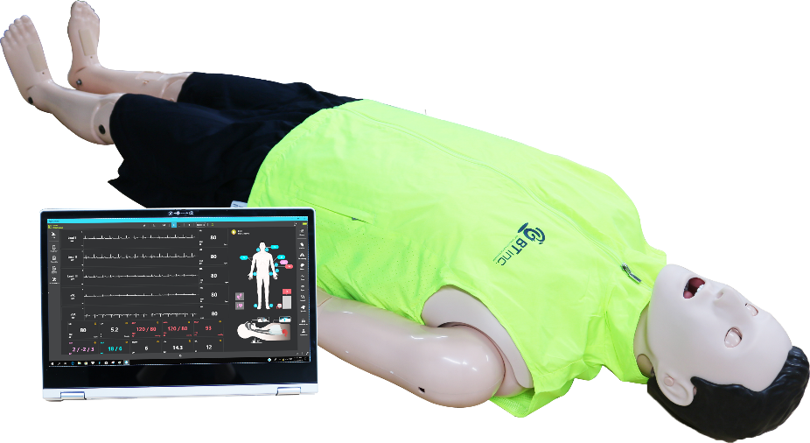
A. FEATURES

- Simulator for adult resuscitation training and evaluation
- Lifelike body structure and silicon; Realistic training
- Various emergency simulation
- Rechargeable battery, completely wireless environment through Bluetooth communication
- Pupillary response; Patient assessment and evaluation
- While chest compression, it generates related pulse and check the ECG change from the patient monitor
- Possible to do chest compression and ventilation at the same time
- Palpate pulse at 4 sites (Bilateral carotid and femoral), possible to adjust the strength or turn on/off
- Virtual patient monitor layout can be adjusted by selecting needed items
- When running scenario, the current patient status can be jumped to the next status by using a transition
- Scenario, Checklist can be exported or imported
- The result data can be printed out by using a printer connected to a facilitator laptop
- The detailed CPR result and even log can be saved to Excel format
- The event log can be sorted by item or time order

B. SPECIFICATION
* EYES
- Light reflex / consensual slight reflex
- Adjust pupil size
- Light reflex speed adjustment : Prompt/Slow
- Eyelids : Open/Closed (Manual)
* Airway
- Head tilt/Chin lift, Jaw thrust maneuver
- Bag-valve-mask ventilation
- Airway intubation
· ETT/LMA/I-gel/Combi-tube insertion
· Detect the right main stem intubation
- Gastric intubation / Gastric inflation
- Check the force applied to the incisors
- Airway obstruction
* Cardiac
- 3-4 Lead ECG
- Defibrillation and cardioversion
- Display Defibrillation shock rhythm/ CPR rhythm
- NIBP, ABP, PAP graphs through S/W
- Pulse palpation synchronized with ECG
· Bilateral carotid and femoral pulses
- Pulse strength adjustment (none / strong / moderate / weak)
- Body temperature (Software)

* Breathing
- Spontaneous breathing
- Unilateral and bilateral chest rise and fall
- Normal Breathing sounds
- ETCO2 Capnography and SpO2 waveform through S/W

* CPR real-time monitoring
- Compression depth and rate / incomplete recoil / hands-off time
- Hand position : Correct / Upper / Lower / Left / Right
- Ventilation volume and time / RR
- Chest compression & Ventilation at the same time

* Vascular access
- IV (right arm)
- Medication (by S/W)

* Speech
- Vocal sound
* Software
- Manual mode / Scenario mode
- Save and print the result
- Offering the virtual patient monitor, virtual defibrillator and pacer function
* Power
- AC/DC adaptor (AC input : AC100~220V, 50~60Hz, 2.5A, DC output : 16.8V, 4A)
- Battery : 14.8v, 10400mAh Lithium-ion

* Weight and size of manikin : 172 x 54 x 24cm, approximately 22kg

C. COMPONENTS
- Adult full body manikin 1ea
- Facilitator laptop 1ea
- AC adaptor 1ea
- Storage case 1ea
- User manual 1ea
- Jacket/pants 1set
- Electrode cover sets for defibrillation (1 set for pads, 1 set for socket)
- IV pad 1ea
- Bottle for IV 1ea
- Simulated blood 1ea
- Cervical collar 1ea

